## ECU ENGL 6700 Design Project Reflection

Pat Brannan

This project was an outreach project in TPC design. Students were required to contact a member of the community who needed a design created or updated. I chose to update the rules board in a local daycare. The owner shared with me that the state daycare board had recommended that she update the caricatures of the children's images on the rule wall to depict images of real children.

This was my favorite project because I put my heart into this one. Tammy Cole is the owner of Danielle’s Playhouse in Moore County, North Carolina. Danielle’s Playhouse is a minority-owned business, and the kids attending are of multiple cultural backgrounds. Ms. Tammy and her staff are loving, dedicated, and passionate about teaching all kids to learn, love, and respect each other.

I learned a great deal about design while completing this project. To make a good design, it is important to begin with good client communication. We spent time during one meeting getting to know each other and determining the type of project Tammy had in mind. My initial idea was to purchase generic images of children from Teachers-Pay-Teachers. My client, Tammy, asked if we could take pictures of children in the classroom, which made the project even more meaningful. My first task was to create a business contract stating how the project would be completed. I learned the intricacies of Canva design next, and how to take pictures and upload them to Canva. Then, when I started to print the pictures, I learned that there are certain weights of paper used for different projects. The project was a great experience for Tammy, the daycare kids, and me. Tammy said they were so excited to see their pictures on the rules wall!

In this picture, you see Tammy Cole’s grandson and my granddaughter.

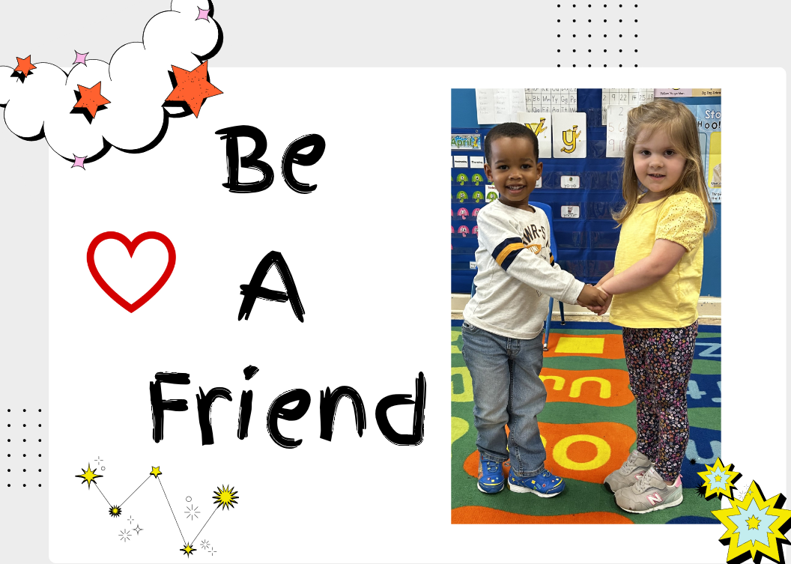

This picture illustrates the classroom diversity that mirrors society, and

the thriving way of life in daycare.

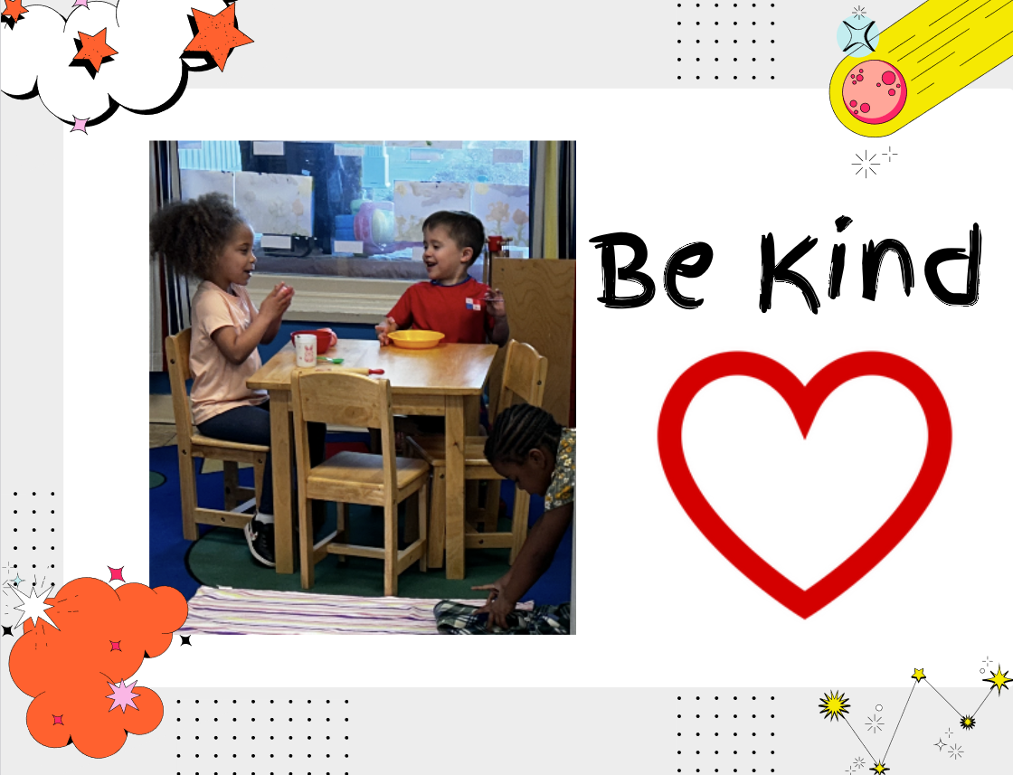

Ms. Tammy shared with me that these two little ones were in the most need of this lesson.

